Name: ___________________ Due Date: Monday 1st of June
Class: Year Two A Teacher: _______________
Attention Students! The school principal has heard that you have all become experts on creating sustainable gardens and making positive food choices. She needs your help. The school’s gardens are no longer sustainable and cannot grow healthy foods. Do you think you can help?

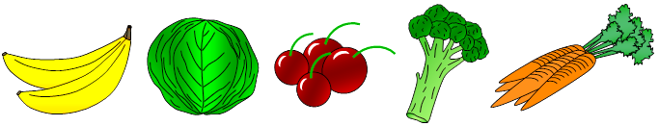

Your task: You are to individually design, create and develop a sustainable garden using the Paint application on your personal computers. Within your chosen design, you are to pick five healthy foods which you will grow. You can either find pictures on the internet, or draw and label your chosen foods. You will then present your garden to the class. Use the table below to ensure you have all components in your task.

Success Criteria:
Have you chosen materials that are sustainable?
Have you chosen five healthy foods?
Have you made your garden using paint?

On the due date, you are required to conduct a 1-2 minute oral presentation in which you must discuss the topics outlined and convince your peers.

When you present you must talk about: |  
Why is your garden sustainable?
Why are the foods you have chosen healthy choices?

*Important Notes*:
Date Commenced – 1st May 2016
Draft Date and Practice of Presentation– 25th May 2016
Presentation/Due Date – 1st June 2016
Time Allowed in Class: You will have 2 lessons in class to complete this task
Overall Result:

Sufficient class time will be given to students to complete this task. This is a summative assessment; therefore, it will be counted towards your final grade.

